7. Perform Basic Video Processing Operations in Python
Aim: To read a captured video in Python and display it in normal speed, slow motion, and fast motion using OpenCV.
Procedure
- Import the OpenCV library.
- Read the captured video file.
- Display the video in normal speed.
- Display the video in slow motion by increasing the delay between frames.
- Display the video in fast motion by decreasing the delay between frames.
Code
import cv2

cap = cv2.VideoCapture("sample.mp4")

if not cap.isOpened():
print("Video not found")
else:
fps = cap.get(cv2.CAP_PROP_FPS)
delay = int(1000 / fps) if fps > 0 else 33

while True:
ret, frame = cap.read()

if not ret:
break

cv2.imshow("Normal Speed", frame)
if cv2.waitKey(delay) & 0xFF == ord('q'):
break

cap.release()
cap = cv2.VideoCapture("sample.mp4")

while True:
ret, frame = cap.read()

if not ret:
break

cv2.imshow("Slow Motion", frame)
if cv2.waitKey(delay * 3) & 0xFF == ord('q'):
break

cap.release()
cap = cv2.VideoCapture("sample.mp4")

while True:
ret, frame = cap.read()

if not ret:
break

cv2.imshow("Fast Motion", frame)
if cv2.waitKey(max(1, delay // 3)) & 0xFF == ord('q'):
break

cap.release()
cv2.destroyAllWindows()
Input
A video file named sample.mp4 saved in the same folder as the Python program.
Output
- Normal Speed: Displays the video at its original speed.
- Slow Motion: Displays the video at a slower speed.
- Fast Motion: Displays the video at a faster speed.
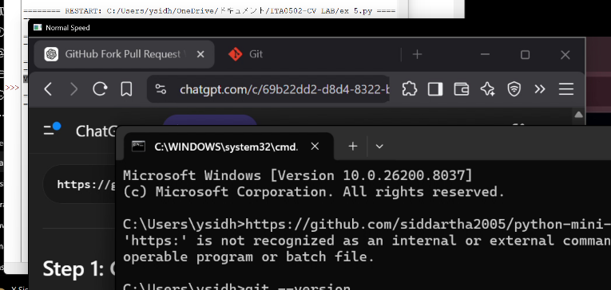

Result
The captured video was successfully read and displayed in normal, slow, and fast motion using Python and OpenCV.

